INTI International College Penang School of Computing
3+0 Bachelor of Science (Hons) in Computer Science, in collaboration with Coventry University, UK 3+0 Bachelor of Science (Hons) in Computing, in collaboration with Coventry University, UK

Coursework cover sheet

Section A - To be completed by the student.

Full Name: Desmond Kok Weng Hin
CU Student ID Number: 14196612
Semester: First semester
Session:
April 2023
Lecturer:
Puteri Nursyawati Azzuri (puteri.azzuri@newinti.edu.my)
Module Code and Title:
4067CEM Software Design
Assignment No. / Title:  Continuous Assessment | % of Module Mark:  50
Hand out Date:  12 May 2023 | Due Date:  Task 1: 02 June 2023, by 11.59pm.  Task 2: 07 July 2023, by 11.59pm  Task 3: 23 June 2023, by 11.59pm.  Task 4: 23 June 2023, by 11.59pm.  Task 5: 23 June 2023, by 11.59pm.
Penalties: No late work will be accepted. If you are unable to submit coursework on time due
to extenuating circumstances, you may be eligible for an extension. Please consult the lecturer.
Declaration: I/we the undersigned confirm that I/we have read and agree to abide by the University regulations on plagiarism and cheating and Faculty coursework policies and procedures. I/we confirm that this piece of work is my/our own. I/we consent to the appropriate storage of our work for plagiarism checking.

Signature(s):

Section B - To be completed by the module leader

Intended learning outcomes assessed by this work:
- Understand and apply appropriate concepts, tools, and techniques to each stage of the software development.
- Understand and apply design patterns to software components in developing new software.
- Demonstrate an understanding of project planning and working to agreed deadlines, along with professional, interpersonal skills and effective communication required for software production.
5. Demonstrate an awareness of, and ability to apply, social, professional, legal, and ethical standards as documented in relevant laws and professional codes of conduct such as that of
the Malaysian National Computer Confederation.
Marking scheme | Max | Mark
1. User Story Mapping | 20
2. Setting up a GitHub
Repository | 10
3. Creating a Class diagram and
design pattern selection | 30
4. Creating a Prototype User
Interface and Usability Testing | 20
5. Discuss the ethical issue
related to the software | 20
Total | 100

The 4067CEM assessment should be completed as a full individual work over the course of the module. The assessment output are only judged at the end of the module and not by the expectations during that week. The assessment should be undertaken individually. All submissions will be checked against each other and the internet for possible plagiarism.

Activities – These activities consist of 50% of your coursework marks. It will be run throughout the semester and there will be a final submission at the end of the semester. These activities consist of activities that will be done in a software design phase.

System

Student Business System for College.

Task 1 – User Story Mapping (20 marks)

The first thing that you need to do is ask the user what they wished for in a system. The user here can be your friends as the system is related to them. Get at least 10 real users to get their feedback. Document their feedback. Use software like Trello to complete this activity.
Output – All the user stories, and backlog with goals, activities, and tasks. In Word format, uploaded it to GitHub.
Due – Week 9 of the semester. 02 June 2023, by 11.59 pm.

Task 2 – Setting up a GitHub Repository (10 marks)

This is where the output of the tasks will be stored, Make sure you register an account, create a repository and your files are uploaded here and it is in an organized manner and can be easily found.
Output – GitHub Repository with Task 1, Task 3, Task 4 and Task 5 documents. Take note the date of the files will be shown so you must follow the due date of each task.
Due – It will be accessed on Week 14 of the semester. 07 July 2023, by 11.59 pm

Task 3 – Creating a Class diagram and design pattern selection (30 marks)

Create a simple Class diagram which should consists of the Classes that might be used to represent the system and the association between them. You don’t have to declare the attributes and operations for this activity. You do have to explain the class responsibility of each class declared. You can use software like StarUML to complete this activity.
Output – A class diagram containing classes and associations. In Word format, uploaded it to GitHub.

Consider the problem and select a suitable design pattern that can be implemented on the problem. Give justification on why the design pattern was chosen. Draw the UML diagram representing your class diagram as a design pattern UML. Include all the abstract class/interface, concrete class, and inheritance (if any) used to represent the problem.
Output – UML diagram representing the design pattern. In Word format, uploaded it to GitHub. Due – Week 12 of the semester. 23 June 2023, by 11.59 pm.

Task 4 – Creating a Prototype User Interface and Usability Testing (20 marks)

Create a Prototype User Interface (hand drawn/digital) of TWO (2) important functions of the proposed system. Come up with usability testing questions. You don’t have to carry out the test, just prepare the questions. You should indicate what you are testing for in the Usability Testing.
Output – A Prototype and Usability Testing Questions. In Word format, uploaded it to GitHub. Due – Week 12 of the semester. 23 June 2023, by 11.59 pm.

Task 5 – Discuss the ethical issue related to the software (20 marks)

Discuss and do a critical analysis of your software in these areas, privacy concerns, intellectual property rights, and effects on society.
Output – A report in Word format, uploaded to GitHub.
Due – Week 12 of the semester. 23 June 2023, by 11.59 pm.

Submission

All tasks needed to be documented in Word format and submitted for SafeAssign checking (Links will be provided before the due date).
Upload the document and the SafeAssign report to your GitHub repository by each task due date. Due – It will be accessed on Week 14 of the semester. 07 July 2023, by 11.59 pm

Marking Rubric for Continuous Assessment

 | Marks Below 40% | Marks in the range 40 – 49% | Marks in the range 50 – 59% | Marks in the range 60 – 69% | Marks 70% and above
User Story | User Story Mapping | User Story Mapping | User Story Mapping | User Story Mapping | User Story Mapping done and does capture most important activities of the system. The breakdown of the user story mapping is excellent and uses software that can assist that process (For example Trello compared to Ms.  Word).
Mapping | not done or User | done at a minimum | done and does | done and does
(20 marks) | Story copied/does  not match the exact | level and does not  capture the | capture several  important activities of | capture several  important activities of
 | system. | important activities of | the system. The | the system. The
 |  | the system. | breakdown of the | breakdown of the user
 |  |  | user story mapping | story mapping is good
 |  |  | can be improved. | and uses software that
 |  |  |  | can assist that
 |  |  |  | process (For example
 |  |  |  | Trello compared to
 |  |  |  | Ms. Word).
Setting up a | GitHub repository | GitHub repository | GitHub repository | GitHub repository exist | GitHub repository
GitHub | does not exist or | exist and some of | exist and most of the | and all of the required | exist and all of the
Repository | cannot be accessed | the required files are | required files are | files are available at | required files are
(10 marks) | or the required files  are not available at | not available at the  time of access. | available at the time  of access. However | the time of access.  However the dates for | available at the time  of access. The dates
 | the time of access. |  | the dates does not | some files does not | on the files follows
 |  |  | follow the required | follow the required | the required
 |  |  | deadline. | deadline. | deadline.
Creating a | The Class diagram | The Class diagram | The Class diagram | The Class diagram | The Class diagram
Class diagram | does not represent | and design pattern | and design pattern | and design pattern | and design pattern
and design pattern selection (30 marks) | the required solution (contains generic or non- related classes  such as admin), the design pattern | represent the required solution but in a very general and incomplete way.  Required classes in | represent the required solution in a partial way. A few  required classes in the design are not | represent the required solution in a satisfactory way. Most  required classes are declared. | represent the required solution in an excellent way. All  required classes are declared.
 | suggested is not | the design are not | declared.
 | suitable for the given | declared.
 | problem.

Creating a Prototype User Interface and Usability Testing  (20 marks) | No prototype were available or the measurement for the usability testing is not clear. | The prototype cover minimalist and trivial design (such as login) and the measurements for the usability testing are not clear. | The prototype cover adequate design and several measurements for the usability testing are not clear. | The prototype cover good design and most measurements for the usability testing are clear. | The prototype cover excellent design and all measurements for the usability testing are clear.
Discuss the ethical issue related to the software  (20 marks) | There is no discussion on the ethical issue or only the theories are pasted back for this component. | There is an attempt to discuss on the ethical issue but no critical  analysis was done | There is an attempt to discuss on the ethical issue with some critical analysis was done | There is an attempt to discuss on the ethical issue with good critical analysis. | There is an attempt to discuss on the ethical issue with excellent critical analysis.

User Story Mapping (Task 1)

1.1 Introduction
In this assignment, our focus was on the Student Business System. Our primary objective was to understand the wishes and requirements of the users through engaging interviews. By gathering their feedback, our intention was to enhance their experience and ensure that the system fulfil their needs.

1.2 User Story Mapping
User Story Mapping is used in agile software development to facilitate effective communication between development team and stakeholders. It empowers the team to break down their project into user stories using sticky notes or digital tools, enabling a clear understanding of user requirements and priorities. When describing a user journey, there are typically three levels of detail name activity, steps and details.
A series of steps must be followed when creating a user story mapping. The initial step is to identify the user persona to ensure that the user story map fulfils their needs. Secondly, define and summarize the goals. Next, arrange and prioritize the user stories on the user story mapping. Lastly, break down the user stories into actionable tasks and create visual representation of the user’s journey.
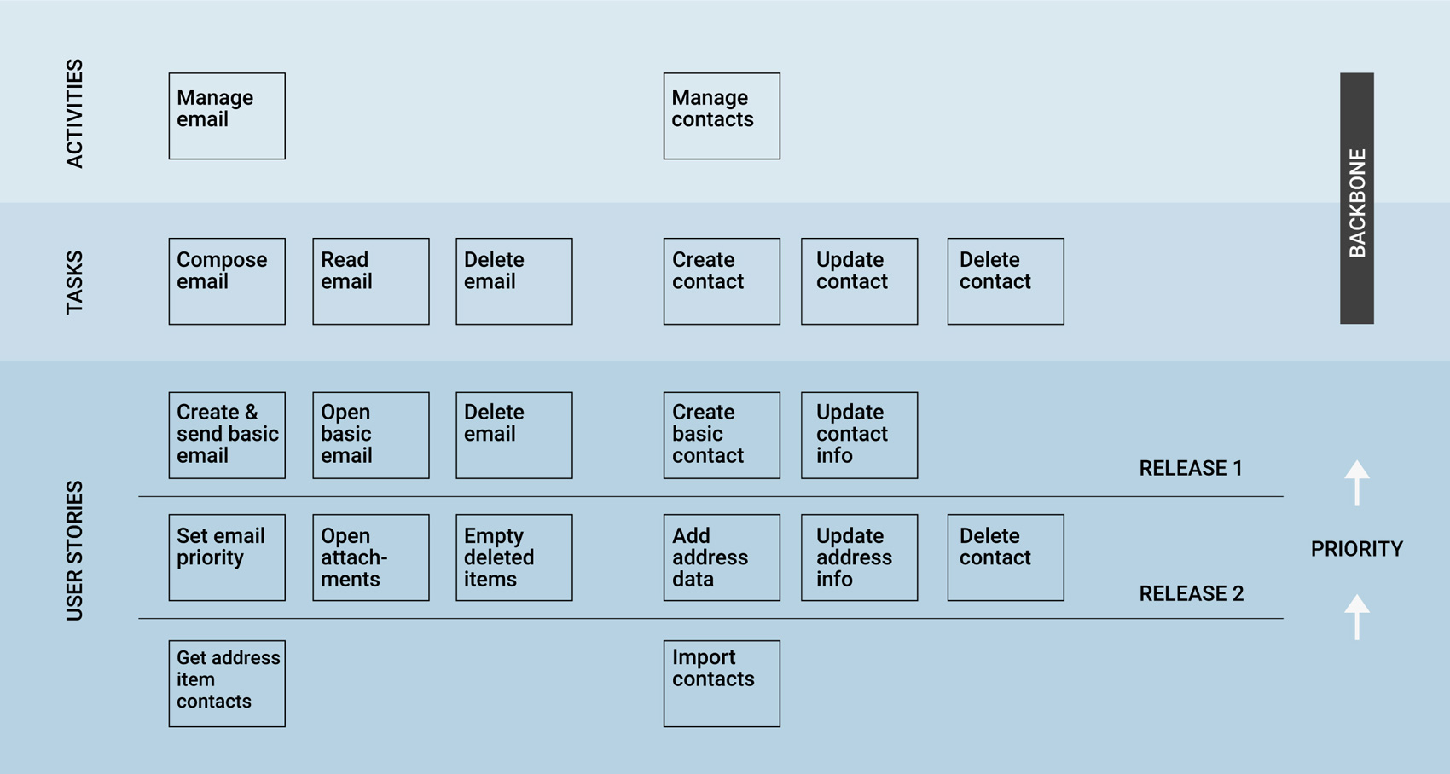
Diagram 1.1 Example of User Story Mapping

1.3 Student Business System
A Student Business System for college is developed to enhance the seamless handling of a range of procedures for students in college. It empowers students to access and manage important information, including academic records and personal details. Additionally, it assists with numerous tasks such as enrolling in courses, managing the financial system and tracking academic progress. Moreover, this system can also offer students the ability to view previous exam results, completed courses and grades with ease due to its centralized platform. The financial management section within the system makes it easier for students to handle their finances such as tuition fees or miscellaneous fees. Students can also conveniently check for any pending payments, review payment history and details and even download invoices. This feature provides a clear overview of their financial status, helping them manage payments more efficiently. In conclusion, the Student Business System plays a vital role in every college as it empowers students to efficiently manage their academic tasks and finances, helping them stay organized and informed about their academic journey through its features.

1.4 Users requirement

1) As a student, I want to have distinctive identification or login so that I can securely access to the system.

2) As a student, I want to be able to update my personal information so that I can ensure my details are accurate and up to date.

3) As a student, I want to register for my courses online so that I can select and enrol in the course of my choice.

4) As a student, I want to view and manage financial system such as checking for pending payments, reviewing payment details, setting up online payment information and download receipts for tuition fees.

5) As a student, I want access to announcements and news of campus so that I can stay well-informed about the latest announcement and activities in order to participate.

6) As a student, I want to view my course timetable so that I can see my class details, assigned lecturer and scheduled time for the course

7) As a student, I want to view the campus maps and direction so that I can easily navigate to various locations on campus.

8) As a student, I want to be able to view and join student society clubs that available in campus

9) As a student, I want to be able to submit my assignment online.

10) As a student, I want to view and access learning resources such as files and lecture notes uploaded by lecturer.

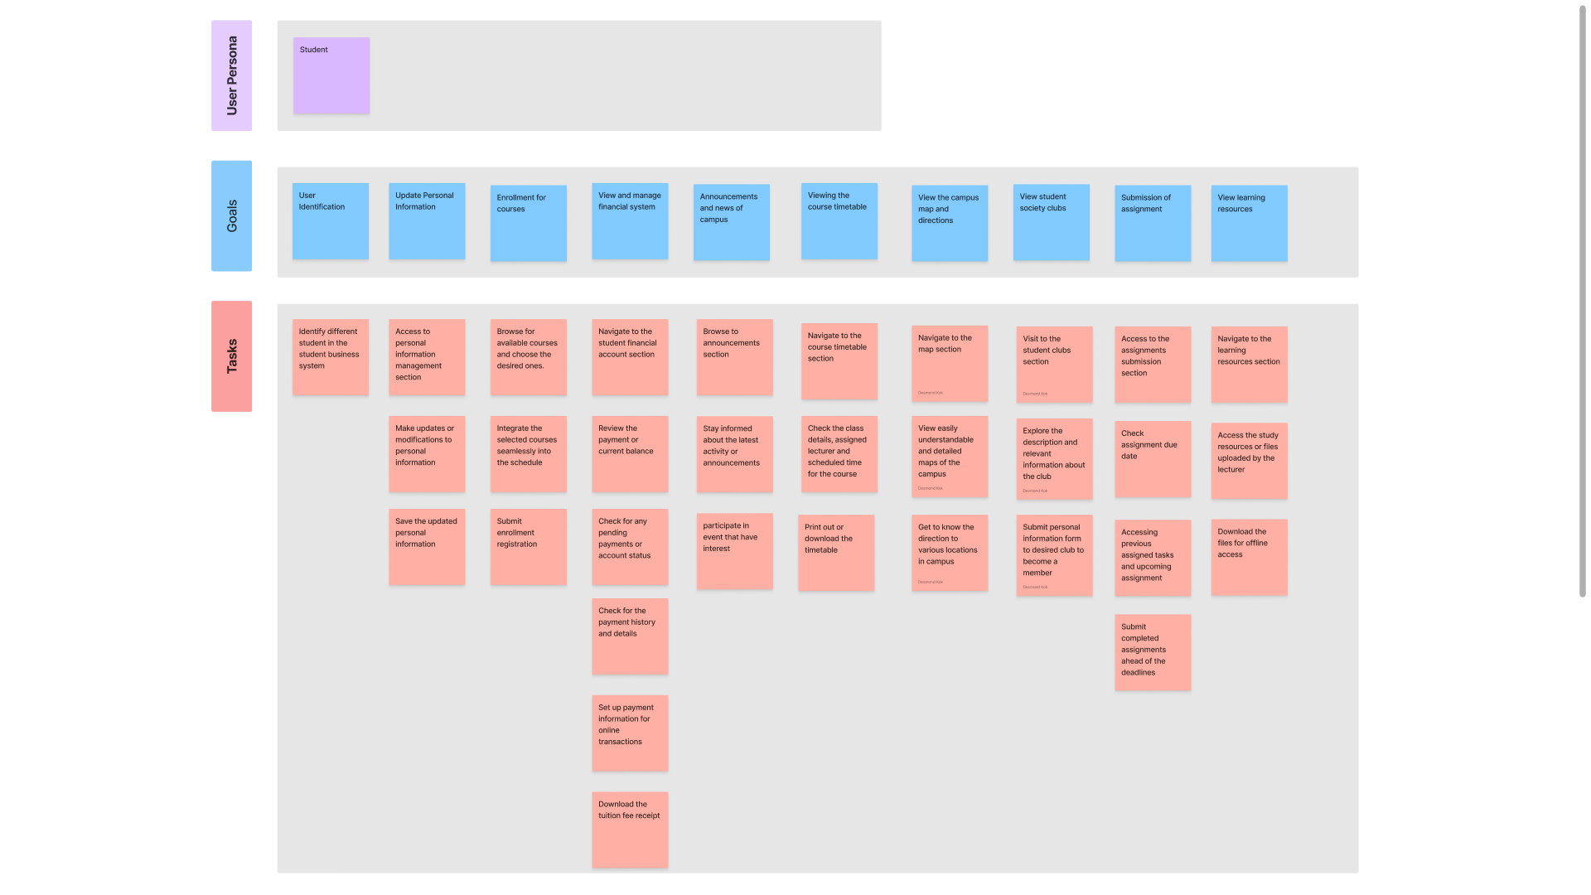
1.5 User Story Mapping

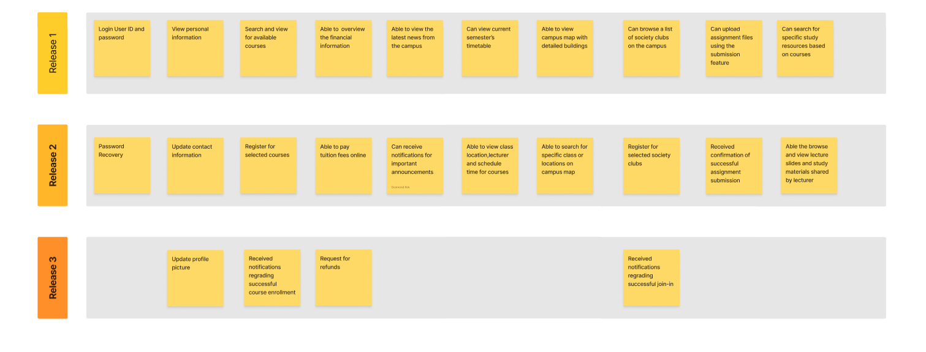

Diagram 1.2 User Mapping story

